Notes on autobiography, split self and negation and comments on the extract of S. King’s On Writing. A Memoir of the Craft (2012[2000])

Main notions: (auto)biography as a genre, split self/point of view, negative structures
Symbols and prototypical images associated with ‘Stephen King’ and ‘Writing’?

☞ How would you start your own autobiography or the biography of a person you are interested in? How do you select facts, stories and anecdotes to report? What kind of perspective/focalisation would you adopt?

In cinema: cf. R. Polansky’s film The Ghost Writer (2010); In fiction: cf. H. Kureishi’s novel The Last Word (2013)

Phenomenon of ‘split self’ in literature (fiction and non-fiction): ⇒ (multiple) nature of identity:
I
present ↔ past
reality ↔ imagination

A split self “may represent the psychological fracturing of a character, the multitudinous nature of the consciousness within us all, or more simply constitute the doppelgangers of sci-fi and fantasy literature” (Neary 2009: 4)

In autobiographical literature: “first-person narratives generally invoke a current self-reporting on a past self since breaks in narrative chronology (such as flashbacks) provide the means of juxtaposing different versions of an individual at different points in time” (Emmott 2002: 153-4).

Autobiography: | Fictional autobiography:
“One of the luckiest things that can happen to you in life is to have a happy childhood. I had a home and a garden that I loved; a wise and patient Nanny; as father and mother two people who loved each other dearly and made a success of their marriage and of parenthood.”  Agatha Christie (1890-1976) An Autobiography, London, Collins, 1977 | “I was born in the city of Bombay… once upon a time. No, that won’t do, there’s no getting away from the date: I was born in Doctor Narlikar’s Nursing Home on August 15th, 1947. And the time? The time matters, too. Well then: at night. No, It’s important to be more precise… on the stroke of midnight, as a matter of fact.”  Salman Rushdie (born 1947) Midnight’s Children, London, Jonathan Cape, 1981

Cognitive frameworks:
- Conceptual metaphors → how we mentally construct the world and create meaning; metaphors as cognitive processes to understand reality; “people do not have one form of consciousness but many” (Lakoff, 1996: 101)
- Mental space theory → to explain why certain instances of co-referentiality may seem illogical, but are actually comprehensible to the reader (e.g. in paintings, in imagination…)
- Connections with Possible World Theory → “including the representation of the beliefs, dreams and fantasies of characters” (Emmott, 2002: 160)

Autobiographical writing as a reflective research process – the development of reflective narratives highlights questions not only of what the story concerns but also how the story is told. Narratives constitute, rather than reflect, reality.

‘Dangers’ with autobiographical narratives: they are not or may be not transparent accounts, since they are filtered, mediated, constructed, and carry as many silences as presences.

However, they allow us to present a sense of time, place and action, and affect that are inevitably missing in other ways of writing (e.g. idea of narrative/biographical format for research in social sciences such as psychology, education, didactics, medicine)

You can now read the S. King excerpt.

Text analysis
Analyse the S. King extract, in particular with reference to the following items or any other that contribute to the general effects produced by the text:

- Point of view/narration
- Lexis
- Foregrounding
- Defamiliarisation
- Metaphor
- Deictic shift (PUSH/POP) (cf. ‘split selves’)
- Text World Theory
- Forms of address
- Graphology
- Negation and hypotheses

An important stylistic element in the S. King passage that we are going to analyse is represented by the use of negation.

What do you think when you read the following? Do not think too much and answer this as quickly as possible!

DON’T THINK OF AN ELEPHANT! (R. Lakoff)

Key importance of negative as well as positive (in cognitive terms)

NEGATION (see Gibbons and Whiteley) is usually conceived in contrast to affirmative expressions. Typically, we can identify three forms of negation:
- syntactic negation, operating via negative particles such as not, n’t with verbs, or no with noun phrases. This category also includes negated terms such as nouns (nothing, nowhere), pronouns (none, nobody), adverbs and conjunctions (nor).
- morphological negation, operating via morphemes attached to words to modify them, with prefixes such as un-, in-, dis (untold, indiscrete), or negative suffixes less- (pointless). There are also some less prototypical negative affixes such as anti- or counter- (countermovement)
- semantic negation, operating via negative lexical items, e.g. negative nouns (death, mistake), verbs (forget), adjectives (scares), and adverbs (nearly). Unlike the other two previous categories, this has a broader scope since often it depends upon interpretation.

Negation function as a cognitive structure:
- when we come across a negate element, we think about the positive image (i.e. that very element) and
- we mentally construct a space/world in which that element is absent. In Text World Theory, we refer to a negative text world, i.e. an image that is unrealised in linguistic terms. Negative forms thus influence the interpretation of the text and its discourse by triggering a kind of lacuna effect (lacuna: a gap or empty space in the meaning making process).

In reality, negation operates via a range of strategies, for examples: grammaticalised metaphors (out of / far from), past tense conditionals (if you had done X, then you could have Y), modality (you should have, I wish you had).

Non-standard double negatives (I didn’t do nothing) is perceived as indicative of poor levels of literacy as multiple negators cancel one another; however, such forms were acceptable prior to standardisation of English and can be found in Chaucer and Shakespeare.
Creative negation in literature:
- “I never was nor never will be”, Shakespeare’s Richard III
- Scout, the narrator in Lee Harper’s To Kill a Mockingbird, lists all the jobs that her father does not do and the pastimes he does not have: he is not the sheriff, does not drive a truck, hunt, fish, smoke, and so forth. In this way, the narrator constructs a text world in which all these activities are not attributed to her, but might be possibilities for other fathers, and consequently this writing will generate expectations in readers.
Negation and ideological effects:
Negation is prototypically utilised in contexts where the positive is asserted or is part of the common background knowledge between participants, and thus it is of primary importance in domains such as advertising. Consider the following advertisement for a Nestle chocolate bar – and think that in the TV version women were shown disguised as men in order to be allowed to buy the product. What’s your interpretation of it?

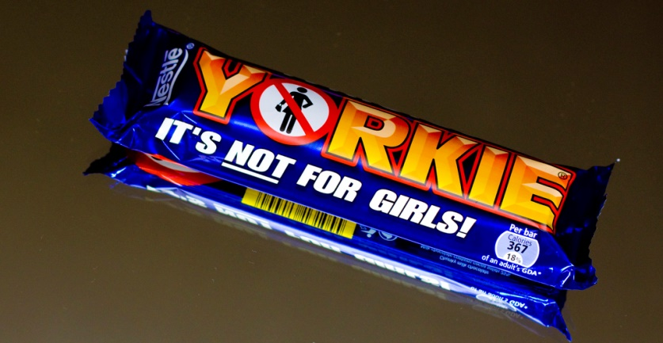

Negation can also be utilised in order to generate the very expectations it defeats. Treating the positive as if it is expected has the potential to project onto readers/hearers a set of beliefs or ideas about the world, and so to reproduce or create social norms/ideologies, i.e. reproduction and reinforcement of stereotypes and clichés defining social roles. The assertion of this ad presupposes that the potential consumer thinks it is, or at least that chocolate bars are for girls (also, notice the term ‘girls’ rather than some other equally loaded words such as ‘women’, ‘ladies’ or ‘females’).

Activity
Classify the types of negation (syntactic, morphological or semantic) present in the following book titles. Be as specific as possible (e.g. try to specify word class or type of affix too). Titles may include more than one negation:

- No-one ever has sex on Tuesday (Tracy Bloom)
- This is not the end (Jesse Jordan)
- Without you, there is no us (Suki Kim)
- All the light we cannot see (Anthony Doerr)
- Breaking the unbreakable (Timothy Atunnise)
- All things cease to appear (Elizabeth Brudage)
- Never let me go (Kazuo Ishiguro)
- The beautifully worthless (Ali Liebegott)
- The sense of an ending (Julian Barnes)
- Deaf sentence (David Lodge)
- The beautiful ones are not yet born (Ayi Kwei Armah)

