A Woman from Palestine
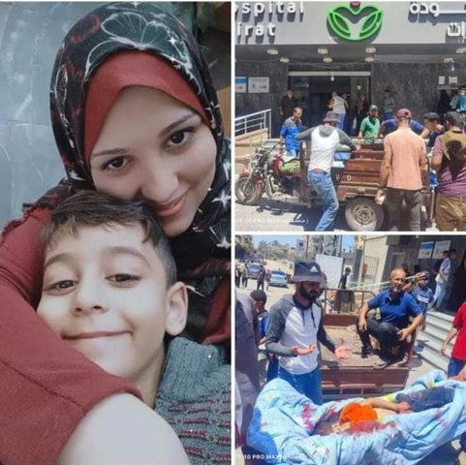
Saida Affouneh - An-Najah University
The nights darkness escapes as soon as the sun shines to lighten our tent. The sun thoughts that we are happily camping in a summer trip. I raise my hands to the sky explaining that the tent is our new home after being displaced several times. Our home has been destroyed. Mahmoud and Ahmad still there under the rubble of our home. I am still waiting for them to be rescued. I am very busy with teaching my children at the tent so they can catch up when they are back to school one day.
Lamees is a clever woman who is completing her Master degree in Islamic university in Gaza while she is a wife and a mother of two children. She was born for an educated family. She loves her family and very proud of her children. She was displaced when they bombed her area and she flee with her family to a tent. The only thing she took with her was her son school bag full of books, one of his toys and light pieces of cloths. Her son has cried hardly because he wants to take his bike but there was no time for that and also since she doesn’t know how long she is going to walk, she ignores his cry to save their lives.
Lamees didn’t sleep deeply for the last ten weeks since she needs to calm down her children and others in the tent who were shouting from hunger and pain. With other moms they try to tell them the story of the hero who will come and bring them food and take them back home. She explains that many of the children stopped believing our stories after three days of repeating it and they prefer to sleep and dreams of nice food and warm homes. We tried asking our children to pray for God to stop the war since God loves Children and answer their calls. This time as usual God never disappointed the children and the tent was bombed and all the Children went to heaven were food and drinks are served freely.
Lamees and her two children were there, the boy left with his mom while the little girl called Karaz stayed to tell the truth to next generations about the story of her family and also to continue her mom education. It is worth to mention here that Lamees enrolled in TESI initiative at An Najah National University after her university was damaged and more than 88000 students were out of universities and more than 600000 schools students were without schooling, even her son Adam was also out of formal school but luckily his mom continue to teach him even through their journey to the paradise.
Lamees was born in 1988 in November 15th when Palestinian Independence declaration was announced for the first time and the sate of Palestine was celebrated by more than 14 million Palestinian around the world.
In the name of God, the Compassionate, the Merciful:
Palestine, the land of the three monotheistic faiths, is where the Palestinian Arab people was born, on which it grew, developed and excelled. Thus, the Palestinian Arab people ensured for itself an everlasting union between itself, its land, and its history……. Therefore, we call upon our great people to rally to the banner of Palestine, to cherish and defend it, so that it may forever be the symbol of our freedom and dignity in that homeland, which is a homeland for the free, now and always…….
Palestinians celebrate Lamees’s birthday yearly with her family through singing the songs of freedom and return. Lamees felt that she was lucky and wished that her name was Palestine and she had asked her family while they didn’t name her after Palestine. Her dad told her that they used to live in Yamen and they didn’t want to shed any unneeded difficulties on their ways from and to Palestine on Borders.

