New York Times 12/05/2023

Britain says it is donating long-range ‘Storm Shadow’ missiles to Ukraine.
The missiles, which are launched from the air, are the latest in a pipeline of military aid delivered to the country by Britain, the United States and other NATO allies.

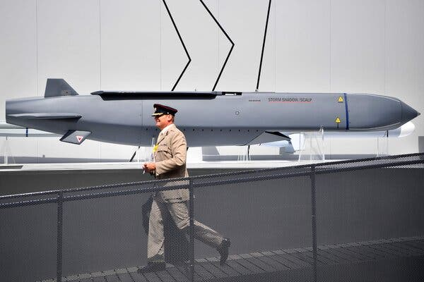
A Storm Shadow missile on display at an air show in 2018 in Farnborough, England.Credit...Ben Stansall/Agence France-Presse — Getty Images

By Matthew Mpoke Bigg and Stephen Castle
- May 11, 2023
Britain is donating long-range Storm Shadow missiles to Ukraine to help it reclaim territory lost to Russia since the start of its invasion, Britain’s defense secretary, Ben Wallace, told Parliament on Thursday.
The missiles, which are launched from the air, are the latest in a pipeline of military aid to the country by Britain, the United States and other NATO allies and come after Ukraine’s request for weapons capable of targeting Russian military infrastructure and troop concentrations far behind the front lines in the war. As the country prepares to launch a counteroffensive, those demands have become more urgent.
Ukraine’s assault could come in the south and east of the country, where Russia holds territory. Kyiv has struck military targets in the occupied southern cities such as Melitopol and Berdiansk with increasing frequency in recent weeks, in a possible preparation for the counteroffensive.
The new missiles may be able to reach those cities, and they might also enable Ukraine to strike military targets in Crimea, a region even further behind Russian lines, which was illegally annexed by Russia in 2014.
“Ukraine has a right to be able to defend itself,” Mr. Wallace said. “The use of Storm Shadow will allow Ukraine to push back Russian forces based within Ukrainian sovereign territory.” Mr. Wallace said he would not describe the weapon’s capabilities in detail but he said they were “not even in the same league” as some Russian weapons. The Russian Kalibr cruise missile, he said, had “a range of over 2,000 km, roughly seven times” that of the Storm Shadow missile.

The State of the War
- The Battle for Bakhmut: In their first gains in the area in months, Ukrainian troops broke through Russian positions outside the embattled eastern city and forced Russian units back from a key position near a canal.
- A.F.P. Journalist Death: A video journalist working for the French news agency was killed by rocket fire near the town of Chasiv Yar in eastern Ukraine.
- A Ticking Clock: Ukraine is feeling pressure from its Western backers to succeed in the counteroffensive that the country is expected to launch soon. Russia seems to be operating on a longer timeline.
- Evacuation Orders: Running short of food, fuel and cash, many civilians in occupied parts of Ukraine are defying a Russian directive to evacuate ahead of the looming counteroffensive.
The Kremlin’s spokesman, Dmitri S. Peskov, said on Thursday that Russia looks “negatively” at the new weapon’s delivery. He said it would “require an adequate response from our servicemen,” but gave no details.
Britain has been at the forefront of donations of military aid to Ukraine and, along with Poland and the Baltic States, has pushed other European countries to supply more aid to the country. Anti-tank missiles supplied by Britain helped Ukraine repel a Russian attempt to seize the capital, Kyiv, last spring, and in January, Britain pledged to send Challenger tanks to Ukraine.
In the past, announcements of weapons deliveries by Britain have been followed by decisions by the United States and other countries to supply similar classes of military aid, but it was not clear whether the pattern would hold with respect to the longer range missiles.
It was also not immediately clear that the United States supported Britain’s move. The Biden administration has held off supplying Ukraine with longer range weapons over concerns that Ukraine could use them to strike targets deep inside Russia, and that President Vladimir V. Putin might respond by escalating the war.
Britain has “received reassurances from Ukraine that these missiles like all other military support we have provided will only be used to defend their sovereign territory in keeping with international law,” said a spokemsan for Prime Minister Rishi Sunak of Britain. It was not clear whether the missiles were already in Ukraine, but the spokesman said that they “have been donated.”
Ukrainian officials say that putting pressure on Russian bases in Crimea is a significant part of their strategy, given the region’s role in supporting military operations elsewhere in Ukraine. U.S. officials have said Ukraine already has the firepower it needs to strike in Crimea. Military analysts say that the reach of the Storm Shadow missiles would, at the least, force Russia to monitor areas that it once thought were out of range of Ukrainian missiles.
It remains unclear whether the Storm Shadow missile will enable Ukraine to strike targets in southern Crimea, including the port city of Sevastopol, which is home to Russia’s Black Sea Fleet. Southern Crimea is about 150 miles south of the frontline in the conflict.
Ben Hodges, a retired lieutenant general who was the commanding general of the U.S. Army in Europe and supports giving Ukraine long-range weapons, said on Twitter that the Black Sea Fleet would now be under threat. “This will give Ukraine capability to make Crimea untenable for Russian forces,” he said.
Marc Santoraand Anatoly Kurmanaev contributed reporting.
Matthew Mpoke Bigg is a correspondent covering international news. He previously worked as a reporter, editor and bureau chief for Reuters and did postings in Nairobi, Abidjan, Atlanta, Jakarta and Accra.
Stephen Castle is London correspondent, writing widely about Britain, including the country’s politics and relationship with Europe.

