Italy Blocks Male Migrants From Leaving Rescue Ships
The new right-wing government appears to be taking a harder line with people who are picked up in the Mediterranean as they try to cross from Libya.

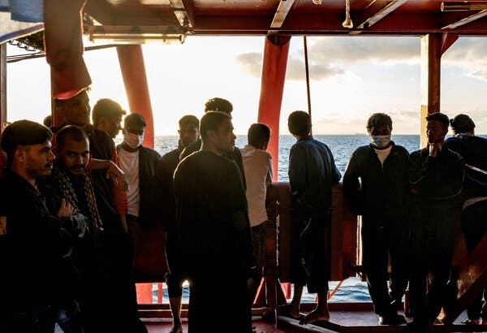
Migrants on board the Ocean Viking rescue ship in the Mediterranean Sea in international waters on Sunday.Credit...Vincenzo Circosta/Agence France-Presse — Getty Images

By Gaia Pianigiani
Nov. 7, 2022
About 250 migrants coming from Libya were stuck in an Italian port on Monday onboard charity-run rescue ships after the new right-wing Italian government refused to allow them to set foot on shore.
In recent weeks, the Italian authorities have failed to assign a port of safety, as required by international law, to four rescue vessels operating in the central Mediterranean Sea, all carrying migrants in distress. While two vessels remain at sea, over the weekend the authorities allowed two other rescue ships to dock in the southern port of Catania.
But they refused to let adult male migrants leave the ships.
“Minors all went down smoothly, but then two doctors came on board and started checking the others’ health with some quick questions,” said Petra Krischok, a communications officer with SOS Humanity, a German rescue group that operates one of the vessels, Humanity 1, who was onboard during the screening. “At the end of their selection, all adult men remained on the floor, not knowing what was going to happen to them.”
One hundred and forty-four migrants left the ship, but 35 men from Egypt, Pakistan and Bangladesh stayed on, and the captain was ordered to take them back to international waters, according to the Italian government. He refused, and a team of lawyers was drafting their asylum applications.
In a similar vetting process, 350 migrants were allowed on Sunday night to leave another rescue vessel, the Geo Barents, operated by the aid group Doctors Without Borders, while 214 stayed on, all adult men.
The vessels that remained at sea were the Rise Above and the Ocean Viking.
Image
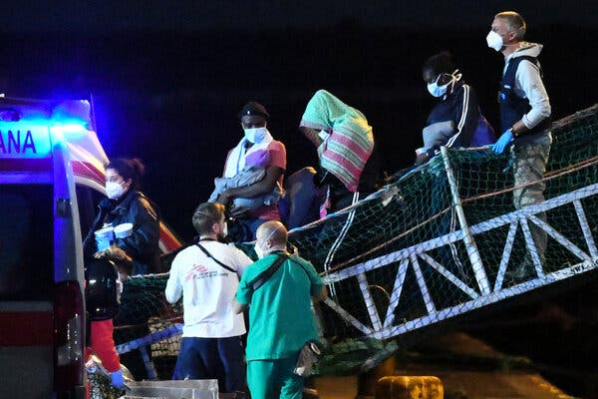
Migrants disembarked on Sunday from the Geo Barents rescue ship in the port of Catania, Italy. More than 200 were kept on board by the Italian authorities. Credit...Salvatore Cavalli/Associated Press

Three migrants dived into the port waters in Catania on Monday afternoon, hoping to reach land. A spokesman said that they were safe and that humanitarian workers were trying to persuade them to return to the ship.

Italy’s New Right-Wing Government
- Challenges Ahead: As she takes office as Italy’s prime minister, Giorgia Meloni faces surging inflation, an energy crisis and increasing pressure to soften the country’s support for Ukraine.
- A Hard Line: The new government has refused to allow male migrants on rescue ships to set foot on shore, in a move reminiscent of those adopted by the anti-immigrant former interior minister Matteo Salvini.
- A Resurgent Hard Right: Long marginalized politically, Giorgia Meloni’s supporters sense a chance to give a final blow to the stigma and shame of their association with Fascism.
- The Coalition’s Linchpin: Ms. Meloni’s turn as prime minister will depend on support from the billionaire media mogul Silvio Berlusconi. So may the health of Italian democracy.

What role do the charity ships play in the central Mediterranean?
A number of rescue vessels run by aid groups have been carrying out search-and-rescue operations in the central Mediterranean since 2015, after the official European Union missions steadily decreased. This immigration route is one of the most deadly across the globe, and over 1,337 people have died this year alone in the crossing.
The boats routinely patrol international waters close to Libya, and often take on migrants from precarious dinghies or dilapidated fishing boats. In accordance with the national authorities, the organizations take the migrants to the closest safe port.

About 15 percent of the migrants who have arrived in Italy this year have been picked up by such aid groups. Most of the remainder were rescued by the Italian Coast Guard, the navy or military vessels, while others arrived safely on their own boats.

Why won’t Italy take in all the migrants?
The government of Prime Minister Giorgia Meloni appears to have decided to take a hard line, a move reminiscent of those adopted by the anti-immigrant former interior minister, Matteo Salvini. Mr. Salvini now oversees the Coast Guard and ports, among other infrastructure.
The government says that the migrants are violating immigration laws and that letting them off the boats would endanger order and security. Officials say that the aid vessels crossed other states’ waters, “expressing the real intention to transfer the people on board to Italy rather than ensuring them the most timely safety,” the government wrote in a decree.
Italy’s interior minister, Matteo Piantedosi, granted assistance to people in emergency and “precarious health” conditions, a measure carried out with the medical screening on board.
Image
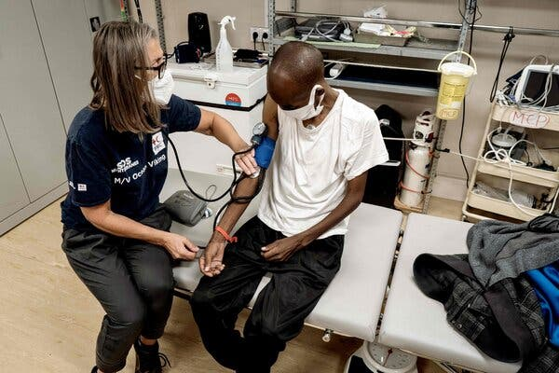
An aid group worker on Sunday checked the health of a migrant on the Ocean Viking off the coast of Italy.Credit...Vincenzo Circosta/Agence France-Presse — Getty Images

Earlier this month, Mr. Piantedosi had tried to engage the German government, as the Humanity 1 flies a German flag, and the Norwegian authorities for the Geo Barents, which flies Norway’s flag. But legal experts say that the flags pertain to the ships’ registration, and do not determine jurisdiction for asylum applications.
The German government urged Italy to lend assistance promptly. In a statement, it said that rescue groups made an “important contribution to rescue human lives in the Mediterranean. Saving people in danger is the most important thing.”
Critics have accused the aid ships of encouraging migrants to make dangerous crossings, and Mr. Salvini has recently characterized their work with migrants as “organized journeys.”

What do humanitarian lawyers says?
Rescue operations at sea terminate once migrants arrive in a safe port, according to international maritime law.
Legal experts also say that national and international norms do not allow governments to choose who gets to leave the ships.
Image
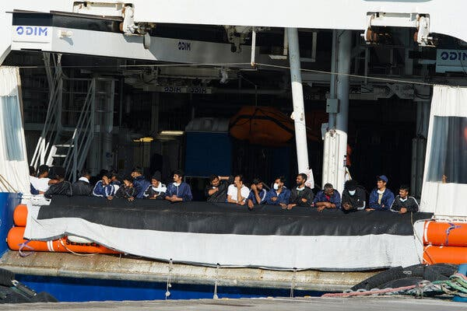
Migrants who remained on the Humanity 1 rescue ship stood at the rail on Monday in the port of Catania.Credit...Antonio Parrinello/Reuters

“Authorities cannot determine who’s vulnerable and who’s not with a medical examination,” Nazzarena Zorzella, a lawyer with ASGI, Italy’s Association for Law Studies on Immigration. “Vulnerable people are not only minors or pregnant women. It’s clear now that migrants undergo torture in Libya” but “not everybody carries visible scars,” she said.

How has Italy handled migrants in the past?
After years of mass immigration largely prompted by unrest after the Arab Spring uprisings and the civil war in Syria, Italy took a tougher stance on immigrants in 2017.
The left-wing interior minister at the time, Marco Minniti, signed an agreement with Libya that starkly curbed the arrival of migrants to Italy and raised questions about Italy’s methods and the humanitarian costs. Mr. Minniti also effectively restricted the activities of charitable groups like those operating the ships.
But a harder line came later, when the anti-migrant government of Mr. Salvini routinely left rescue ships packed with African migrants marooned at sea for weeks. He is currently on trial on accusations of abduction for blocking the migrants on board.

Gaia Pianigiani is a reporter based in Italy for The New York Times. @gaia_pianigiani

