**Completa con gli aggettivi dati**

**Alta – lisci – neri – verdi – rossi – azzurri – corti – castani – lunghi – biondi – ricci – basso – marroni - ondulati**

CAPELLI

**COLORE**

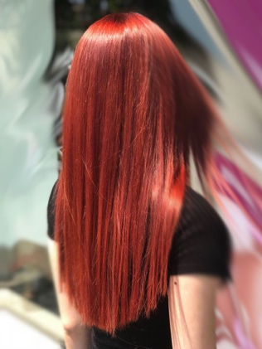 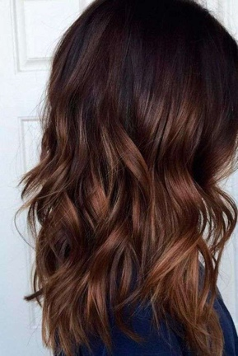 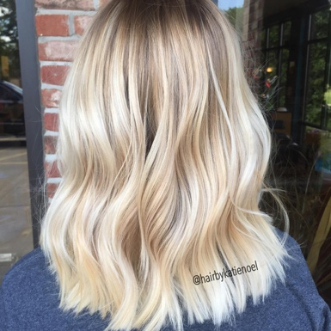 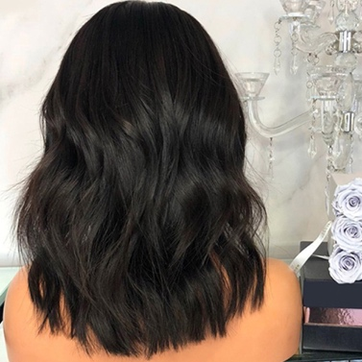

_________________ ________________ ___________________ ___________________

**TAGLIO**

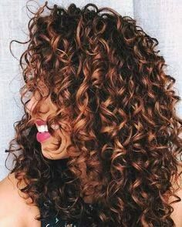 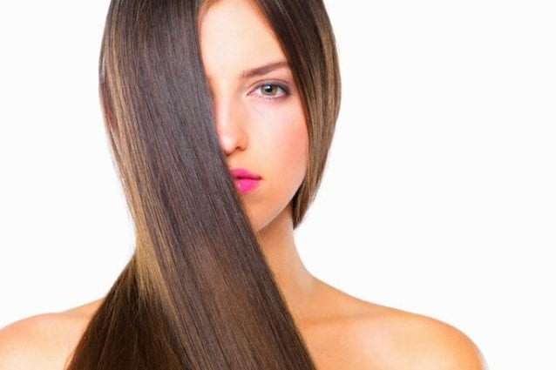 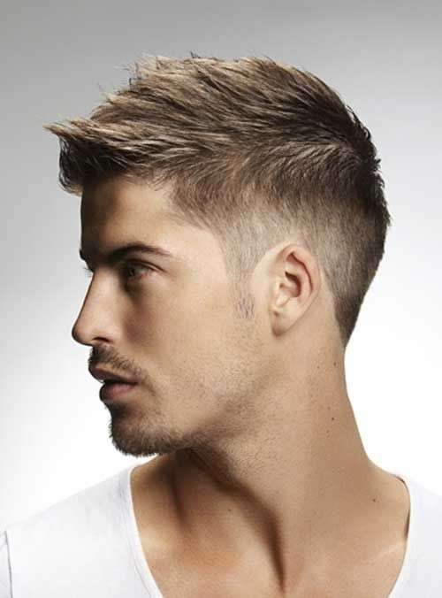 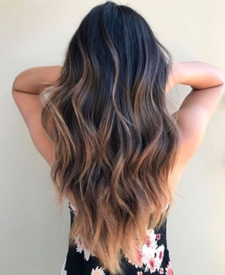

_________________ ______________________ ______________ ______________

______________

OCCHI

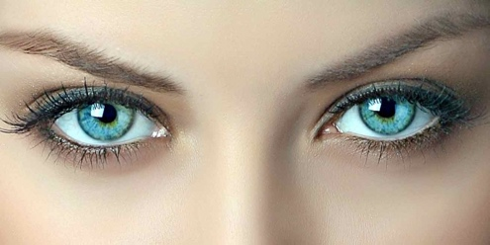 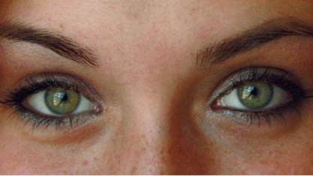 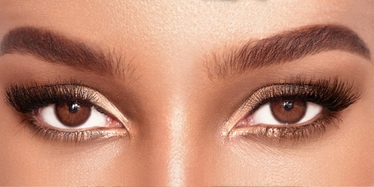

_________________________ _____________________ _____________________

CORPO

 

_________________ __________________